John G. Bagley
Manufacturer’s Rep for the following companies:
(Servicing Minnesota, Iowa, No. Dakota and So. Dakota)

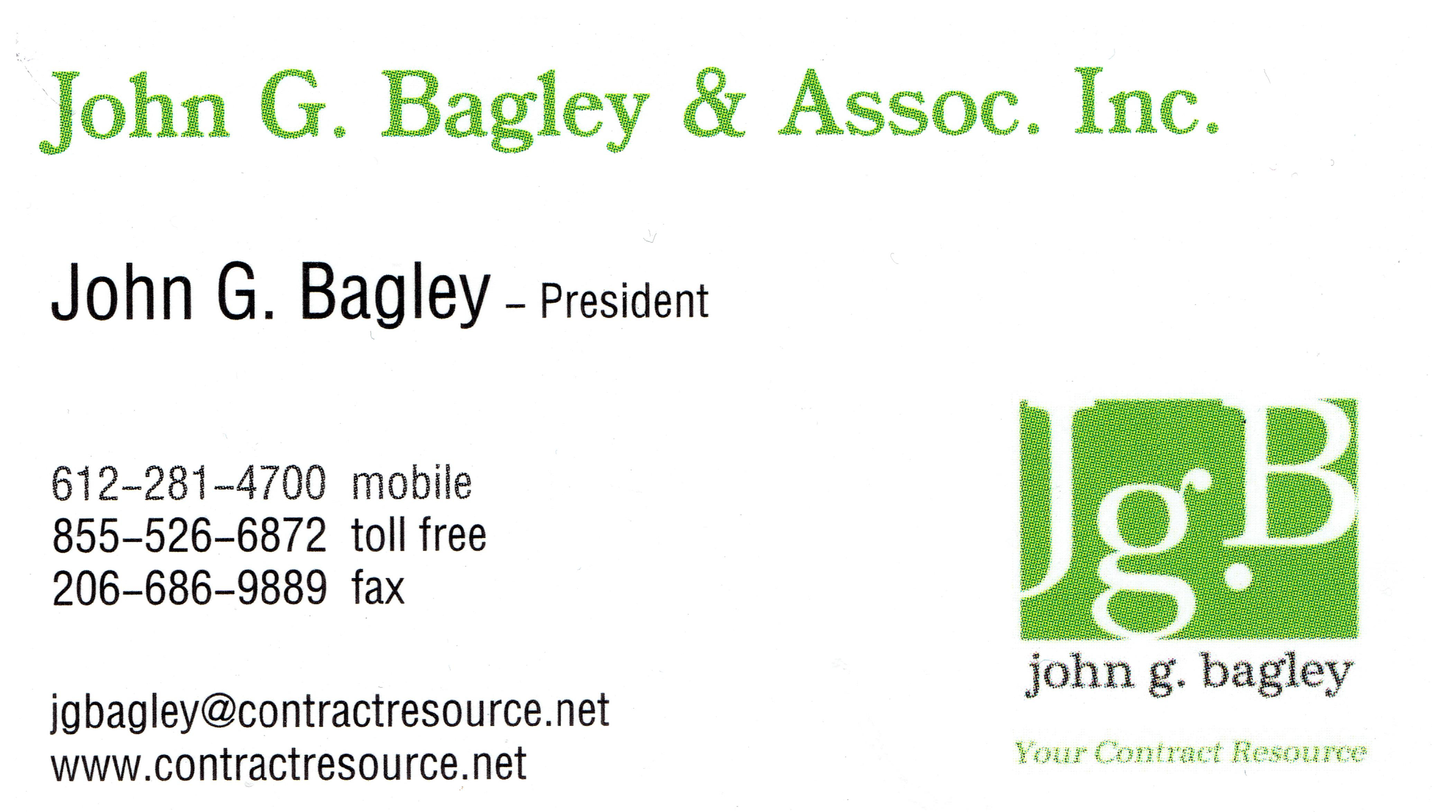

John’s e-mail: jgbagley@contractresource.net
Mary’s e-mail: Mary@contractresource.net

Century Furniture https://www.centuryfurniture.com/
Upscale, elegant, premium casegoods and seating for public areas and suites. Custom size and finish options.

Corsicana Mattress https://www.corsicanamattress.com/
A 50+ year old mattress company, 3rd largest supplier of mattresses to the USA, producing on average $1 million of product per day. Approved by most all Brands (Marriott, IHG, Hilton) and preferred by Choice, Best Western and America's Best Value. Save 20% or more on net cost.

Brookline Furniture www.brooklinefurniture.com Domestic seating, chairs, sofas and sleepers, Brand approved, Hilton preferred

Creation Hospitality http://www.creationhospitality.com/
Casegoods (custom and branded hotel properties), stone and vanity bases giving the most cost-effective solutions to its clients by sourcing directly from factories globally.

Craftmade Lighting / Fans https://www.craftmade.com/
Fans including blade and light options. Hardwire lighting, sconce, vanity and outdoor.

Culp Hospitality Fabrics https://www.culphospitality.com/
Contract fabrics for furniture, drapery, window treatments and room accessories. Prints, base cloths, PVC free, recycled leather and vinyl. Nanotex technology, ‘i-clean’

ISA International http://havaseat.com/ MADE IN AMERICA
A North America company of 43 years. Stack chairs, bar stools, wood & metal SIDE/ARM & dining chairs. Custom design capability as well as hotel branded programs.

Lang Hospitality https://www.langfurniture.net/ MADE IN AMERICA
Guestroom casegoods, preferred by Choice Hotels and Wyndham Hotels. Short lead time, custom capability and competitive pricing.

Malar Lighting https://malarlighting.com/ Guestroom and Public Space lighting. Hotel brand approved

Office Star Products https://www.officestar.net/
Ergonomic chairs, task chairs, furniture and office accessories for contract hospitality.

Prince Seating http://princeseating.com/
Wood, steel and aluminum chairs, tables and barstools. Import with competitive pricing.

Read Window Co - www.readwindow.com MADE IN AMERICA
Est. 1981. Turn-key provider offering measuring, sourcing, fabrication & installation. Roller shades (motorized), drapery, soft goods. Hotel Brand approved

Renaissance Lighting and Metal Furniture- https://renaissancecontractlighting-furnishings.com/index.htm MADE IN AMERICA
Branded and Custom lighting fixtures. Site furniture, architectural walls, outdoor furniture

Rize Bed Bases, Frames and Platforms - https://rizehome.com/collections/commercial-products Steel bed bases, frames and bed platforms

Table Topics https://tabletopics.biz/ MADE IN AMERICA
Table Topics provides custom tables in the hospitality industry. Their patented resin coating, “Acralyte”, is a UV curing process offering an unmatched level of scratch, mar and chemical resistance. Veneers, laminates, solid woods and digital images.

Uttermost https://www.uttermost.com/
Mirrors, Art, Lamps, Wall Décor & Accessories. Custom and standard framed mirrors.

Woodard https://www.woodard-furniture.com/hospitality.html
Indoor and outdoor seating, tables, umbrellas and fire pits. Cast & extruded aluminum, wrought iron & all-weather wicker.

